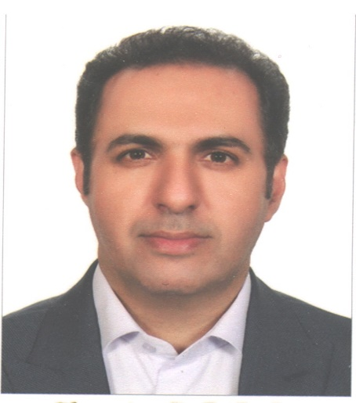

**Seyed Ali Banifatemeh**

**CURRICULUM VITAE**

|  |
| --- |
| 1. PERSONAL INFORMATION |

**Date of birth:** 10 April 1983

**Place of birth:** Yazd, Iran

**Marital Status:** Married

**Nationality:** Iranian

**Address (work):** IranUniversity of medical science , Hemat Hw, Tehran, Iran.

Phone: (+98)-21-86701

**Contact:**

Cell phone: +98-9132565128

Email:[**Banifatemeh_cardio@yahoo.com**](mailto:Banifatemeh_cardio@yahoo.com)

|  |
| --- |
| 2. EDUCATION |

* **Secondary School Diploma in Experimental Sciences**

National Organization for development of Exceptional Talents, Ebne Sina Center, Mehriz, Yazd, Iran Overall GPA: 19.20/20 (1997-2001)

* **Doctor of Medicine (MD) (2001-2008)**

Faculty of Medicine, Shahid Sadoghi University of Medical Sciences, Yazd, Iran

* **Board-certified General cardiology (2011-2015)**

Faculty of medicine, Shahid Sadoghi University of Medical Sciences, Yazd, Iran

* **Fellowship in Interventional Cardiology (April 2018-expected September 2019)** Faculty of medicine, Iran University of Medical Sciences, Rajaei heart center, Tehran, Iran
* **Fellowship in Advanced Endovascular (September 2022-expected April 2023)** Faculty of medicine, Iran University of Medical Sciences, Rajaei heart center, Tehran, Iran

|  |
| --- |
| 3. CURRENT POSITION |

* Assistant Professor of interventional cardiology, Rasool Akram Medical and research center , Iran University of Medical Sciences, Tehran, Iran

|  |
| --- |
| 4. MEMBERSHIPS |

* Iranian Medical Council with the M.C. No. of 121613

* Iranian Society of Atherosclerosis
* Iranian Society of interventional cardiology

|  |
| --- |
| 5. WORK EXPERIENCE |

**5.1CLINICAL PRACTICE**

* Elite Military service Duty at " ValiasrMilitary training center " Yazd, Iran (Dec 2008-March 2010)
* General cardiologist at “khatam Govermental Hospital”, Kerman, Baft, Iran (December 2015- March 2018)
* Interventional cardiologist at Rasool Akram Medical and research center, Iran University of Medical Sciences, Tehran, Iran (from October 2019 until now)

**5.2RESEARCH**

* Afshar Cardiovascular research committee, Shahid Sadoghi University of Medical Sciences, Yazd, Iran (2012-2015)
* Rajaei cardiovascular research Committee, Iran University of Medical Sciences (2019-2020)

|  |
| --- |
| 6. AWARDS, HONOURS and SCHOLARSHIP |

**ACADEMIC**

* Rank 180th in Iran University Entrance Exam, 2001
* Rank 3th in basic science comprehensive exam, Shahid Sadoghi University of Medical Sciences, 2004
* Rank 2th in fellowship entrance exam, 2017

|  |
| --- |
| 7. RESEARCH INTERESTS |

* Interventional cardiology
* Peripheral Interventions
* Structural Interventions
* Public Health
* Evidence-Based Medicine

|  |
| --- |
| 8. PUBLICATIONS |

**ARTICLES**

1. Banifatemeh SA, Sadeghipour P, Alemzadeh-Ansari MJ, Fakhrabadi AA, Zolfaghari F, Zahedmehr A, Mohebbi B, Kiani R, Shakerian F, Rashidinejad A, Hosseini Z, Firouzi A. Role of stent oversizing in patients undergoing primary percutaneous coronary intervention. An open-labeled randomized controlled trial. Minerva Cardiol Angiol. 2021 Oct;69(5):513-521. doi: 10.23736/S2724-5683.20.05396-7. Epub 2020 Dec 1. PMID: 33258566.
2. Forouzannia S K, Mohammadi S M, Mirhosseini S J, Abdollahi M H, Moshtaghion S H, Hosseini H, et al. Comparing Effects of Continuous Insulin Infusion with or without Subcutaneous Glargine Insulin on Glycemic Control in Diabetic Patients Undergoing Coronary Artery Bypass Graft (CABG). IJDO 2009; 1 (1) :5-10  
   URL: <http://ijdo.ssu.ac.ir/article-1-11-en.html>
3. Seyed Khalil Forouzan nia*, Seyed Jalil Mirhosseini, Seyed Hossein Moshtaghion, Mohammad Hassan Abdollahi, Habibolah Hosseini, Hamzeh Dehghanizadeh, Seyed Ali Bani fateme, Seyed Mohammad Hosseini. Right pleural versus mediastinal drainage following elective off-pump coronary artery bypass.Tehran University Medical Journal; Vol. 68, No. 12, Mar 2011: 726-731
4. Abbas Andishmand, Seyed Ali Banifatemeh*, Zohreh Behnamfar, Seyed Mehrdad Mirvakili. Acute Myocardial Infarction with Normal Coro-nary Arteries Following Blunt Chest Trauma; a Case Report. J.Biol.Today’s World. 2014 September; 3 (9): 198-200
5. Mahmood Emami, Seyed Ali Banifatemeh*, Zohreh Behnamfar, Seyed Mehrdad Mirvakili. Non-compaction with coronary artery disease; a Case Report. J.Biol.Today’s World. 2014 June; 3 (6): 133-135

|  |
| --- |
| 9. CONGRESS PRESENTATIONS |

* Speaker in 12th interventional cardiology annual seminar focusing on complication, Tehran, Iran Dec 2018.
* Speaker in Iranian society of interventional cardiology 11th conference and 9 th webinar, PCI on coronary artery graft, Tehran, Iran Sep 2022.
* Speaker in 8th Iranian Joint Cardiovascular Congress, Acute Coronary Syndrome case base session, Tehran, Iran June 2023.

|  |
| --- |
| 10. TECHNICAL SKILLS |

Software knowledge including all standard of Microsoft office software, image processing, statistical analysis and graphs generation, using **SPSS**, **End Note**

|  |
| --- |
| 11. LANGUAGE SKILLS |

1. Persian (Native)
2. English (Fluent)
3. Arabic (Beginner)